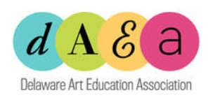
Artwork Release Form
I hereby authorize the Delaware Art Education Association, hereafter referred to as DAEA, to publish artwork and or photographs for use on their website, publications and social/marketing materials advocating for the DAEA.
I acknowledge that my participation is voluntary and I will not receive any financial compensation of any type associated with the publication of the artwork. The first name of the artist and age will be acknowledged on all publications.
Authorization

Name/Description of Artwork ____________________________________________________________

_____________________________________________________________________________________

Name of Artist ___________________________________________________Age: _________________

Artist Signature ________________________________________________________________________

Street Address_________________________________________________________________________

City ______________________________________ State ____________ Zip ______________________

Parents/Guardians Name________________________________________________________________

Parent/Guardian Signature __________________________________________ Date ______________

Name of Art Educator_______________________________________ NAEA/DAEA ID #______________

Art Educator E-mail Address ______________________________________________________________

