Keynote Speakers:
Richard Cleaver, Ceramic Sculptural Artist
Tim Lautzenheiser, Music Educator & Author
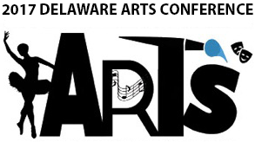
Hosted by Dover High School,
One Dover High Drive, Dover, DE

All Arts Educators are invited to attend - Dance, Media Arts, Music,
Theater and Visual Art

Dynamic workshops, door prizes, continental breakfast and box lunch included

Register Today!
http://delawaremea.org/2017-sac-registration/
Friday, October 6, 2017

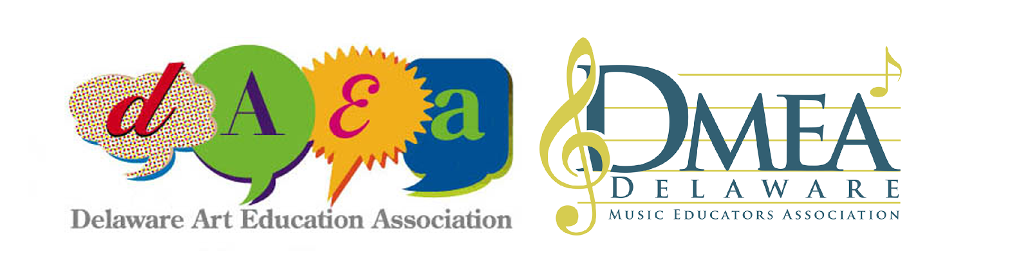
$35 Members/ $50 Non-members
After September 22nd - $50 Members/ Non-members

Questions?
Music Educators - contact dmeasmd@gmail.com or visit delawaremea.org
Visual Art Educators - contact kristen.leida@gmail.com or visit daea.weebly.com
Dance, Media Arts, & Theater Educators - contact jenbolandart@gmail.com

To receive clock hours, you must also register on PDMS - DMEA Course # 25166, Section # 45736 or DAEA Course # 2370, Section # 45735
Name ____________________________________________________________ Discipline __________ Member ID # ____________________
School District __________________________________ Email _____________________________________ Grade Level(s) ______________
Choice of Lunch: Ham & Provolone * Ham, Capicola, & Provolone * Turkey & Provolone * Veggie

